|  |  |
| --- | --- |
| No. of Pages | **10** |
| No. of Questions | 7 |

**Department of Computer Science and Engineering**

**FINAL EXAMINATION FALL 2016**

**CSE421/EEE 465: Computer Networks**

**Total Marks: 100 Time Allowed: 2.5 Hours**

* Answer **Any** **Five (5)** questions out of **Seven (7)** questions.
* Figure in bracket [] next to each question indicates marks for that question.

###### Question No. 1

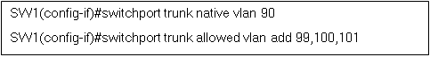

**Figure No. 1**

1. What is the purpose of giving the first and second commands shown in the above **Figure no.1**? If both of the commands are not given, what will be the differences? [4 marks]

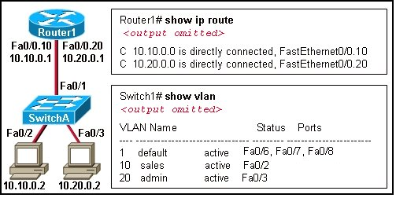

**Figure No. 2**

1. Refer to the exhibit shown above in **Figure No.2**. A network administrator has segmented the network into two VLANs and configured Router1 for inter-VLAN routing. If a new VLAN 30 (Guest) is to be configured for the network diagram shown, what steps should the network administrator follow for VLAN 30 to be operational? [4 marks]
2. What is the effect of the command “SW1(config)#delete flash:vlan.dat”? What is flash? [3 marks]
3. Why would ‘Router on a Stick’ create a bottle neck? [3 marks]

R1(config)#**int f0/0.1**

R1(config-subif)#**encapsulation dot1q 10**

R1(config-subif)#**ip address 172.17.2.33 255.255.255.224**

R1(config-subif)#**end**

R1(config)#**int f0/0.2**

R1(config-subif)#**encapsulation dot1q 20**

R1(config-subif)#**ip address 172.17.2.66 255.255.255.224**

R1(config-subif)#**end**

R1(config)#**int f0/0.3**

R1(config-subif)#**encapsulation dot1q 30**

R1(config-subif)#**ip address 172.17.2.99 255.255.255.224**

R1(config-subif)#**end**

R1(config)#**int f0/0**

R1(config-if)#s**hutdown**

R1(config-subif)#**end**

**Figure No. 3**

1. Refer to the commands shown in the above **Figure no. 3**, [2+4 marks]
   1. Why is the shutdown command given only to fa0/0?
   2. Suppose that the router receives a frame on physical interface f0/0.The source IP of the frame is 172.17.2.70/27 and the destination IP address is 172.17.2.125/27. What will the router do with the frame and why?

###### Question No. 2

|  |  |  |  |  |  |  |
| --- | --- | --- | --- | --- | --- | --- |
| **Node A Table** | | |  |  |  |  |
|  | **A** | **B** | **C** | **D** | **E** | **F** |
| **A** | 0 | 5 | 2 | 3 | ∞ | ∞ |

[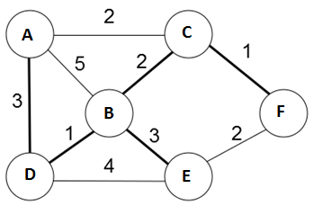 your reader’s attention with a great quote from the document or use this space to emphasize a key point. To place this text box anywhere on the page, just drag it.]

|  |  |  |  |  |  |  |
| --- | --- | --- | --- | --- | --- | --- |
| **Node C Table** | | |  |  |  |  |
|  | **A** | **B** | **C** | **D** | **E** | **F** |
| **C** | 2 | 2 | 0 | ∞ | ∞ | 1 |

|  |  |  |  |  |  |  |
| --- | --- | --- | --- | --- | --- | --- |
| **Node B Table** | | |  |  |  |  |
|  | **A** | **B** | **C** | **D** | **E** | **F** |
| **B** | 4 | 0 | 2 | 1 | 3 | 3 |

**Figure no. 4**

1. For the above **Figure no. 4**, the tables represent the routing table of Router A, C and B at a certain point of time. Router A receives updates from B and C routers. All routers are running Distance Vector algorithm. What will be the status of the routing table of Router A be after receiving the updates? (Use Dx(y) = min{c(x,y) + Dy(y), c(x,z) + Dz(y)} for explaining your answer) [7 marks]
2. Refer to the routing table of Router R1 shown in **Figure no. 5** below. [2 + 4 marks]
   1. After how many seconds will Router R1 receive a routing update from its neighbour Router R2, (represented by the next hop IP address 192.168.3.1)?
   2. What will occur if Router R1 receives updates regarding networks 192.168.1.0/24 and 192.168.7.0/24 but not for 192.168.7.0/24 network for the next 240 seconds?

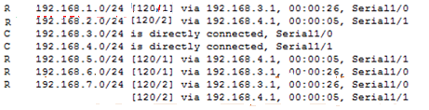

**Figure no. 5**

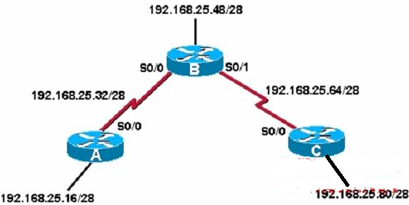

**Figure no. 6**

1. Refer to the **Figure no. 6** above. Should we turn on “auto-summary” in routers A and B to keep our routing tables small? Why or why not? Explain briefly. [ 4 marks]

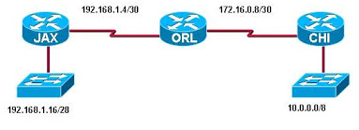

**Figure no. 7**

1. JAX, ORL and CHI routers of **Figure no. 7** are all running RIPv2. Routing updates are being sent through all of the interfaces of all three routers. This is creating congestion in the internal networks, how can we solve this problem? [3 marks]

###### Question No. 3

1. Link state routing protocol uses Dijkstra’s algorithm. Now using Dijkstra’s algorithm, compute the shortest path from **A** to all the other network nodes using **Figure No. 8**. (Use the separate sheet given) [4 marks]

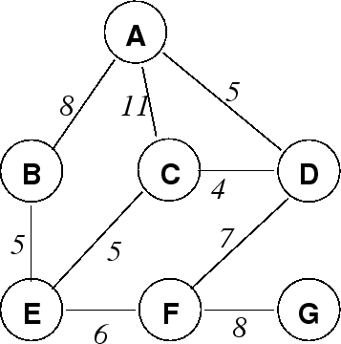

**Figure No. 8**

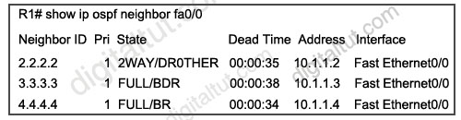

**Figure No. 9**

1. Refer to the **Figure no. 9**, explain the states that router R1 is in with its neighbors. [3 marks]
2. A serial link is configured to operate at 64 kbps using the command “clock rate 64000” issued on the DCE interface. The bandwidth and cost commands were not used. What will be the calculated OSPF cost for the link? [3 marks]
3. Assume all the routers of **Figure no. 10** are running OSPF.
   * 1. Identify the router IDs of R1, R2 and R3. [3 marks]
     2. State which routers will be the DR and BDR and why? [3 marks]

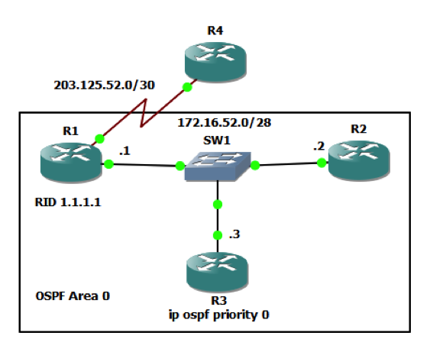

**Figure No. 10**

1. Refer to **Figure no. 11** below; which route will Router R1 take to route packets to Server A and why? [4 marks]

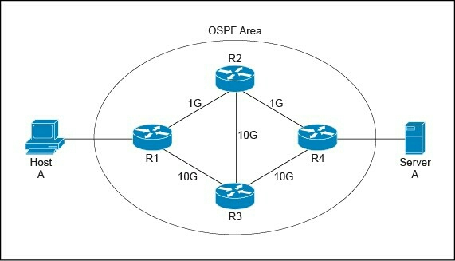

**Figure No. 11**

###### Question No. 4

1. Refer to the **Figure no. 12** below. Write the commands which are necessary for the router R1 to dynamically translate any addresses of the private network 10.10.0.0/24 of the company to a public address pool of 5 addresses starting from 130.16.32.131/26 with PAT. [6 marks]

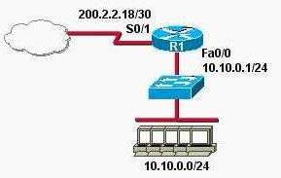

**Figure No. 12**

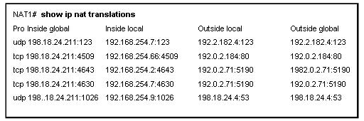

**Figure No. 13**

1. The above output shown in **Figure no. 13**, shows entries of what? Explain the first line. [4 marks]

**<output omitted>**

**ip dhcp excluded-address 192.168.1.1 192.168.1.10**

**ip dhcp pool 192Network**

**default-router 192.168.1.1**

**dns-server 192.168.1.12**

**netbios-server 192.168.1.13**

**!**

**interface FastEthernet 0/0**

**ip address 192.168.1.11 255.255.255.128**

**duplex auto**

**speed auto**

**!**

<output omitted>

**Figure No. 14**

1. Refer to router configuration output shown in **Figure no. 14**. Hosts connected to this router are having problems with DHCP. Find the problem/s? [4 marks]
2. What is the difference between DHCP manual allocation and dynamic allocation? [3 marks]

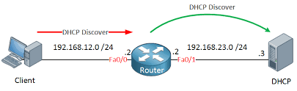

**Figure No. 15**

**Figure No.5**

1. What commands must be given in the router for the DHCP Discover packet to reach the DHCP Server shown in **Figure no. 15?** [3 marks]

###### Question No. 5

1. In the network layer, state the function/s of the following [4.5 Marks]
   1. IP Protocols
   2. Routing Protocols
   3. ICMP Protocols
2. Suppose that the data bytes of an original datagram is 4040 bytes which includes 40 bytes of header. The datagram is to be sent from PC1 to PC2. The datagram has to go through the network R1 –R2. The network between R1 and R2 only allows maximum data frames of 1200 bytes. The identification number of the first datagram is 111 and the first byte position is 80 not 0. Header length is 40 bytes. So fragment the data accordingly using the following table structure shown in **Figure no. 16.** [5 marks]

|  |  |  |  |  |
| --- | --- | --- | --- | --- |
| Identification  No. | Total length  field | Fragmentation  offset | M: more fragment bit | Range of data bytes in the frame |

**Figure No. 16**

C:\WINDOWS\system32>ping google.com

Pinging google.com (74.125.43.99) with 32 bytes of data:

Reply from 74.125.43.99: bytes=32 time=132ms TTL=50

Request time out.

Request time out.

Request time out.

**Figure No. 17**

1. Refer to the output shown in **Figure no. 17** above, explain what is happening here? [4 marks]
2. In the trace route application how does the source know when it has reached the destination? [2.5 marks]

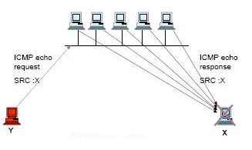

**Figure No. 18**

1. Refer to **Figure no. 18** above, what kind of attack is this, explain briefly? [4 marks]

###### 

###### Question No. 6

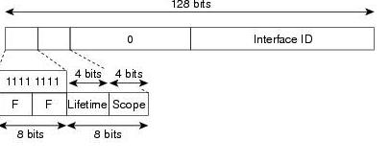

**Figure No. 19**

1. Refer to the **Figure No. 19** above, what type of IPv6 address is it? What is the purpose of the 4 bits field “Scope”? [3 marks]
2. In IPv6 fragmentation is no longer done, but there will be links having MTU less than the PDU size. How does IPv6 handle these situations? [4 marks]
3. Draw the SLAAC process of DHCPv6. And also explain the two ways that the host can generate its IPv6 address. [5 marks]
4. One of the functions of ICMPv6 is DAD, what is it for and how is it done? [4 marks]
5. Refer to the **Figure No. 20** below, how will the two IPv6 hosts communicate with each other? [4 marks]

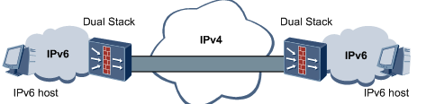

**Figure No. 20**

###### Question No. 7

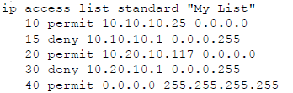

**Figure No. 21**

1. Referring to the above **Figure no. 21**, what do you have to do if you need to permit the IP address 10.20.10.116 instead of 10.20.10.117? Explain in steps or use commands. [4 marks]
2. Referring to the above **Figure no. 22**, write a numbered standard ACL that will not allow 192.168.30.0/24 network to access both the 192.168.10.0/24 and 192.168.20.0/24 networks. Remember to mention which router you are writing the ACL and also place the ACL at the appropriate interface of the router. [4 marks]
3. Refer to **Figure no. 22**, where would you place a standard ACL that will only allow PC3 to telnet into the Router R3? [2 marks]
4. Refer to **Figure no. 22**, write a named extended ACL in ISP that will
   1. Allow hosts of 192.168.10.0/24 and 192.168.20.0/24 to have secured web access to the Web Server only, any other type of access to the 209.165.201.0/27 network by the above-mentioned two networks will be denied.
   2. Allow only hosts from 192.168.30.0/24 network to telnet into the Web Server.
   3. Allow any type of traffic from any other networks to the Web Server. [Do not forget to place the ACLs appropriately.] [4+3+3 marks]

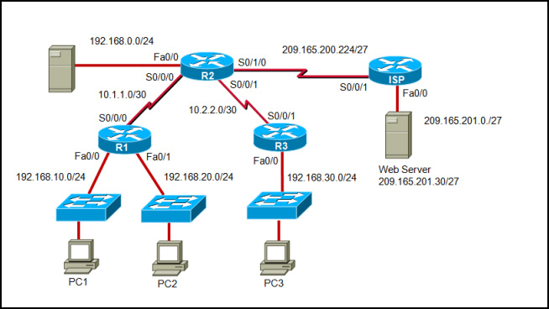

**Figure No. 22**

##### THE END